



AI-Driven Companion for Emotional Well-being and Security

Title of the Proposed Solution: Guardian AI: A Holistic AI Solution for Mental Well-being and Security

Team Name : Neural Nonsense

Theme Chosen : AI for Human Mind & Behaviour

Details of Team: Team Representative - Hariharasudhan M, Senegan N

* **Problem Statement & Need Analysis**

In modern society, many individuals, particularly bachelors and those living alone face emotional distress and loneliness due to a lack of companionship and emotional support. Stress, anxiety, and a lack of social interaction can negatively impact mental health and productivity. Furthermore, individuals require a personal assistant to manage their schedules and security systems to ensure their safety at home.

Addressing these issues with an AI-driven solution can significantly improve emotional well-being, enhance security, and optimize personal productivity.

**Existing solutions and their limitations:**

* + - **Virtual Assistants (Alexa, Siri) handle tasks but lack deep emotional intelligence and personalized voices.**
    - **Virtual Assistants (Alexa, Siri) handle tasks but lack deep emotional intelligence and personalized voices.**
    - **Home Security Systems (Ring, Nest) detect motion but lack AI-driven emergency response and user-specific commands**.

* **Proposed AI-Solution**

Our AI solution will:

* + - AI provides personalized voice interactions, mimicking familiar voices to reduce stress and enhance emotional connection.
    - Act as a personal assistant by scheduling daily routines, reminders, and adaptive learning tailored to the user’s IQ level.
    - Function as a security system that detects motion and alerts emergency contacts upon security command activation.

**How is AI utilized to solve the problem?**

**Our AI analyses speech and text for emotion recognition, adapts voice synthesis for user comfort, manages tasks with smart scheduling, and enhances security through motion detection and emergency response.**

* **Technical Approach**

**Free Tools**:

* + - **OpenAI Whisper:** High-accuracy speech recognition and speech-to-text conversion, essential for understanding and analyzing user input.
    - **Deepgram:** Real-time transcription API that enhances voice-based AI interactions with fast and accurate speech processing.
    - **Vosk:** Offline speech recognition toolkit with support for multiple languages, useful for privacy-focused applications.

**Advanced AI Tools (Subscription-based):**

* + - **GPT-4 API:** Advanced natural language processing and response generation, making user interactions more human-like and emotionally aware.
    - **AWS IoT & Lambda:** AI-driven security monitoring and emergency response processing using motion sensors.

**These tools enhance project efficiency by:**

* + - **Accelerated Development**
    - **Improved Real-Time Performance**
    - **Enhanced User Experience**.
    - **Scalability & Future Upgrades**.

**Architecture and workflow of the solution:**

Component Diagram (system design):

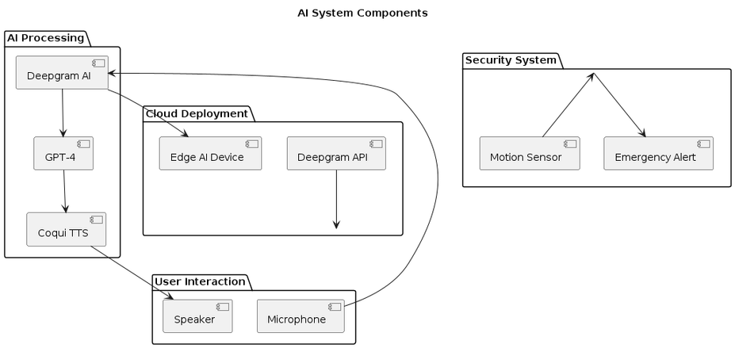Decision Tree (AI decision logic):

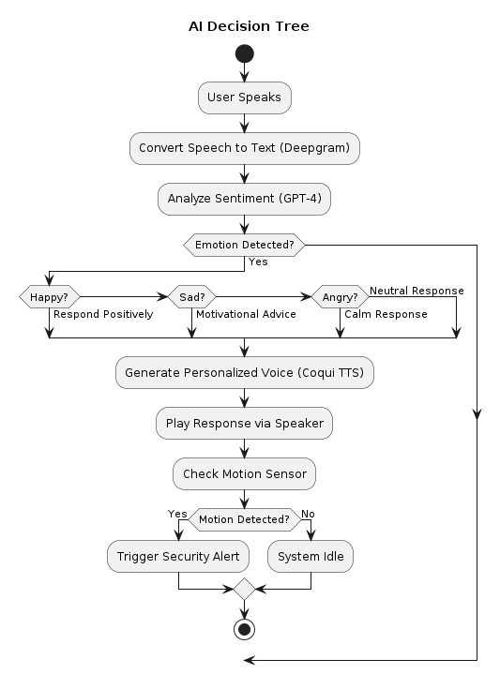

**Implementation Methodology**

1. **AI Model Development**
   * + Train deep learning models for speech recognition, sentiment analysis, voice synthesis, and emotion detection.
2. **Integration & Deployment**
   * + Deploy AI models on a cloud-based system with real-time API communication.
3. **User Interface Development**
   * + Build web and mobile apps with customizable voice-based interaction.
4. **Security & Privacy Implementation**
   * + Implement AI-driven motion detection with encrypted, privacy-compliant data handling.
5. **Testing & Optimization**
   * + Rigorously test across scenarios and optimize AI models for real-time accuracy.
6. **Deployment & Maintenance**
   * + Deploy AI on edge/cloud platforms with continuous learning for improvements.

* **Data & Model Training**

**Dataset used (source, preprocessing steps):**

* + - **Emotion Detection Dataset:** Open datasets like EmoReact, CMU Multimodal Opinion Sentiment, and MELD.
    - **Voice Synthesis Dataset:** Open-source datasets like Mozilla Common Voice.
    - **Security Dataset:** Motion detection datasets for training AI to recognize human activity patterns.

**AI model selection and training process**

* + - Train emotion detection using transformer-based NLP models.
    - Use deep learning models (WaveNet, Tacotron) for voice synthesis.
    - Train motion detection AI using sensor data processing techniques.

**Performance metrics :**

* + - **Emotion detection accuracy:** >85%
    - **Voice synthesis quality:** Mean Opinion Score (MOS) >4.0
    - **Motion detection sensitivity:** >90%

* **Implementation**

**How the solution will be developed and deployed?**

* + - Develop and deploy AI models in a cloud-based system with embedded voice, security features, and remote access via mobile and web apps.

**Resource requirements**

* + 1. **Hardware Requirements**

**Edge AI Devices - Raspberry Pi 4/5**

**Audio & Voice Processing Hardware - Microphone -** MEMS Microphones (e.g., Knowles SPH0645)

**Speaker -** Compact Embedded Speakers for Edge AI devices

**Visual & Security Hardware:**

* + - **Motion Sensors -**  PIR Sensors for human motion detection

**Processing & Storage:**

* + - **Cloud GPU & TPU instances -** Google TPU (for efficient AI model processing)
    - **Local Storage & Edge Compute:** SSDs for data caching and offline processing.

ii. **Software Requirements**

**AI & Machine Learning Models:**

* + - **Emotion Recognition & NLP -** OpenAI GPT-4
    - **Voice Processing & Synthesis -** OpenAI Whisper and Coqui TTS

**Cloud & Deployment Platforms - Deepgram AI**

**Edge AI & Embedded Software - Jetson SDK** and **Raspberry Pi OS + Python AI frameworks**

**Challenges and possible risks**

* + - Ensuring AI understands diverse emotions accurately.
    - Ethical concerns regarding privacy and data security.
    - High computational power requirements for real-time processing.
* **Future Scope & Scalability**

**Potential improvements and future developments**

* + - Advanced deep learning models for enhanced emotional intelligence.
    - Integration with VR/AR for immersive emotional support.
    - Expansion to workplace settings for employee well-being monitoring.

**How can the solution be scaled for a larger impact?**

* + - Expand to multilingual support for global users.
    - Develop enterprise-level solutions for businesses and healthcare applications.
    - Partner with mental health professionals for AI-assisted therapy solutions.
* **Conclusion**

This AI-driven solution integrates emotional support, personal assistance, and security into a single device. It enhances users’ well-being, manages daily schedules, and ensures security through AI-driven motion detection.

**Expected impact of the project**

* + - Improved mental health for individuals living alone.
    - Optimized personal productivity and security.
* **References** 
  + - [OpenAI,](https://arxiv.org/abs/2303.08774) research papers.
    - [Mozilla Common Voice dataset](https://commonvoice.mozilla.org/en) for voice synthesis.
    - Research papers on AI in mental health and security systems.